

L.M. Geoinformatics Engineering

AA 2021/21

HYPERMEDIA APPLICATIONS

Design Document

**Date**: 25/07/2021

# **Authors**: Matteo Bresciani – mtr. 944639 - matteo.bresciani@mail.polimi.it

Gabriele D’Ascoli – mtr. 944275 - gabrieleangelo.dascoli@mail.polimi.it

**Link: https://toptech-polimi.herokuapp.com/**

**Contents**

1. Abstract……………………………………………………………………………………………………………………………………….…..3

2. Graphical Representation……………………………………………………………………………………………………….…….….4

2.1 C-IDM Diagram .4

2.1.1 C-IDM Notes………………………..……………………………………………………………………………………………………..5

2.2 P-IDM Diagram………………………………………………………………………………………………………………………………...6

2.2.1 P-IDM Notes……………………………………………………………………………………………………………………………....7

3. Content tables……………………………………………………………………………………….………………………………………...8

4. Mapping Content tables into pages……………………………………………………………………………..….……………..10

5. Visual Design (Wireframe and screenshots)………………………………………………………….………………………..11

5.1 Commented low fidelity wireframes……………………………………………………………………………………………….11

5.2 Commented high fidelity wireframes……………………………………………………………………………………………..21

6. Scenarios……………………………………………………………….……………………………………………………………………….31

6.1 Case 1………………………………………………………………………………………………..…………………………………………..31

6.1.1 Textual narrative………………………………………………………………………………………………………….…………..31

6.1.2 Sequence……………………………………………………………………..…………………………………………………………..31

6.2 Case 2…………………………………………………………………………………………………………..………………………………..33

6.2.1 Textual narrative…………………………………………………………………………………………………..………………….33

6.2.2 Sequence…………………………………………………………………………………..……………………………………………..33

6.3 Case 3………………………………………………………………………………………..…………………………………………………..35

6.3.1 Textual Narrative………………………………………………………………………………………………………………………35

6.3.2 Sequence……………………………………………………………………………..…………………………………………………..36

**7. DB Design……………………………………………………………………………………………………………………….………………39**

7.1 ER ………………………………………………………………………………………………………………………………………………….39

7.2 Relational Tables………………….…………………………………………………………………………………………………………40

1. **Abstract**

This document contains the decisions made regarding the design specification of the project of the Hypermedia Application (Web and Multimedia) course for the academic year 2020/2021.

The project consists in designing and implementing a website for an ICT company.

The document is composed by the IDM models (interactive dialogue model) that define which are the main concept of the website (C-IDM) also providing a logical description of the pages structure (P-IDM), the scenarios to better understand the main idea behind the navigation and the contents provided by the website the content tables with their mapping with the pages, then the low and high fidelity wireframes of our website and how it will look like after the development and at the end the Entity Relationship diagram that describe the structure of the database.

**Every decision has been made in order to optimize the content of the website, making it simple and attractive.**

**Diagrams and Wireframes are created using *draw.io and Figma.***

1. **Graphical Representation**

2.1 C-IDM

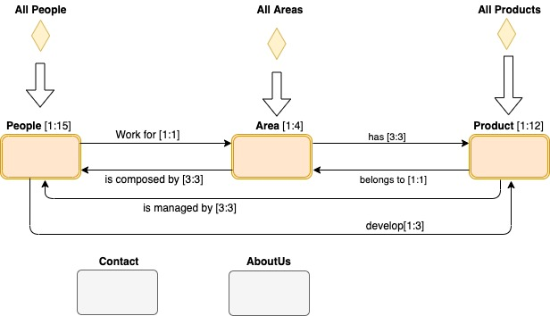

Figure 1. C-IDM describes the content of the web site in the large

2.1.1 C-IDM Notes

The diagram is composed by

Topics:

* **Contacts:** information regarding the different company’s locations, include a form to fill with information to get in contact with the company.
* **About** **us**: general information about the company.

Kind of topics:

* **Area**: working fields of the company.
* **Product**: services offered by the company.
* **People**: all people working in the company, related to each area.

Groups:

* *All areas*
* *All products*
* *All people*

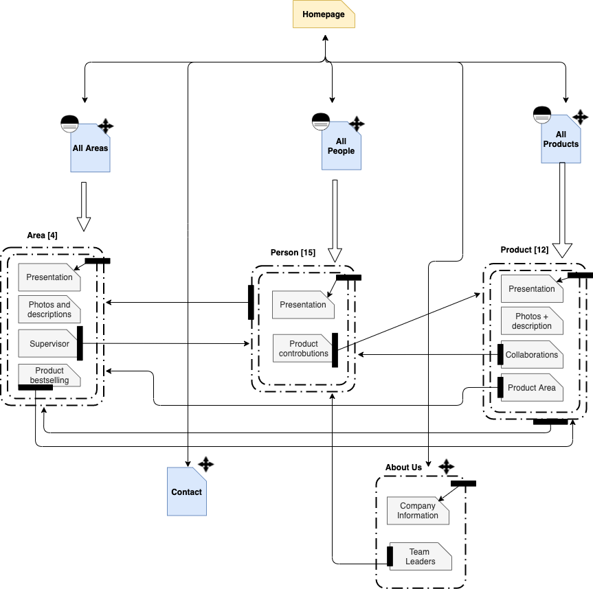2.2 P-IDM

Figure 2. Page Interactive Dialogue Model

2.2.1 P-IDM Notes

P-IDM Diagram is an Interactive Dialogue Model, and it is based on C-IDM. It describes the navigational architecture of the website.

We can notice that for each page aggregation (dashed lines in the diagram), the content spans a single physical page in the website. This means that there are no more internal relations we need to highlight: all the links are visible in this main P-IDM Diagram.

1. **Content tables**

Content tables describe the content of our website in the small.

Each component of the C-IDM Diagram corresponds to a table ( see Chapter 2.1 C-IDM Diagram).

In our case, each table corresponds to a single page of the website.

|  |
| --- |
| **GROUP OF TOPICS: All areas** |
| ***Title:*** Text (max 20 char)  ***Subtitle:*** Text (max 20 words) |
| ***Items Preview*:**LIST OF [Area image; Area name; Area description]  ***Page description*:** Text (max 100 words) |

|  |
| --- |
| **GROUP OF TOPICS: All people** |
| ***Title*:** Text (max 20 char)  ***Subtitle:*** Text (max 20 words) |
| ***Page presentation*:** <Image, Text (max 100 words)> |
| ***Items Preview*:**LIST OF [Area name, LIST OF (Person image; Person name; Person role)] |

|  |
| --- |
| **GROUP OF TOPICS: All products** |
| ***Title*:** Text (max 20 char)  ***Subtitle:*** Text (max 20 words) |
| ***Items Preview*:**LIST OF [Product image; Product name; Brief Description] |
| ***Development strategies:*** [<Image1, Text>, <Image2, Text>, <Image3, Text>] |

|  |
| --- |
| **KIND OF TOPIC: Areas** |
| ***Area Name****:*Text (max 30 char) |
| ***Area brief description:*** [<Image1, Text>, <Image2, Text>, <Image3, Text>] |
| ***Area long description*:**[Image1, Text1 ( max 300 words), Image2, Text2 ( max 300 words), Image3, Text3 ( max 300 words)] |
| ***Bestselling:*** “Bestselling” |
| ***Bestselling product:*** [Image, Name, Text (max 50 char)] |
| ***Supervisor:*** “Supervisor” |
| ***Area manager:***[Person image; Person name, Person role] |

|  |
| --- |
| **KIND OF TOPIC: Products** |
| ***Product Name****:*Text (max 30 char) |
| ***Product image:*** Image |
| **Product long description:**Text (max 300 words) |
| ***Functionalities section*:** “Functionalities” |
| ***Product functionalities***: [Text1 ( max 50 words), Text2 ( max 50 words), Text3 ( max 50 words)] |
| ***Collaborations section:*** “Collaborations” |
| ***Related Team:***[Area image; Text (max 100 char)] |
| ***Related Area manager:***[Person image; Person name, Person role] |

|  |
| --- |
| **KIND OF TOPIC: People** |
| ***Person anagrafic/image/citation/contribution:*** [Text1 (max 50 char), image, Text2 (max 50 words), Text3 (max 50 words)] |
| ***Contributions title:*** “Contributions”  ***Managed Products:*** LIST OF[Product image; Product name; Text (max 50 char)] |
| ***Form title:*** “Send a message!” |
| ***Contact us /form:*** multipart/ form-data |

|  |
| --- |
| **TOPIC: Contacts** |
| ***Title*:** Contact  ***Contact us/Image:*** Image |
| ***Practical info/addresses/contacts:*** [Text1 (max 50 words), Text2 (max 50 words), Text3 (max 50 words), Text4 (max 50 words)] |
| ***Form title:*** “Contact us!” |
| ***Contact us /form:*** multipart/ form-data |

|  |
| --- |
| **TOPIC: About Us** |
| ***Title*: “**About Us” |
| ***Overview*:** [3 images, Text1 (max 300 words), Text2 (max 300 words), Text3 (max 300 words)] |
| ***Leadership team title:* “**Leadership team” |
| ***Leadership team overview***: [ 3 images, Name1 (max 50 char), Name2 (max 50 char), Name3 (max 50 char), Role1 (max 20 char), Role2 (max 20 char), Role3 (max 20 char)] |

1. **Mapping Content Tables into Pages**

The mapping of the content tables is useful if the content of one or more tables is divided over several pages.

This chapter would be a repetition of the previous one.

*See chapter 3. Content tables.*

1. **Visual Design (Wireframes and Screenshots)**

Visual Design is dividend in two parts: Low fidelity design and High fidelity design. In Low fidelity design, the initial model of pages is presented and all links are highlighted. In High fidelity design, the final design of pages is showed by to screenshot.

* 1. Commented low fidelity wireframes

Low fidelity wireframes show the base structure of pages: fixed Header on the top, fixed Footer on the bottom and variable content in the middle. They also highlight links (where links are and which is their category) and the orientation information (in order to understand where user in the website).



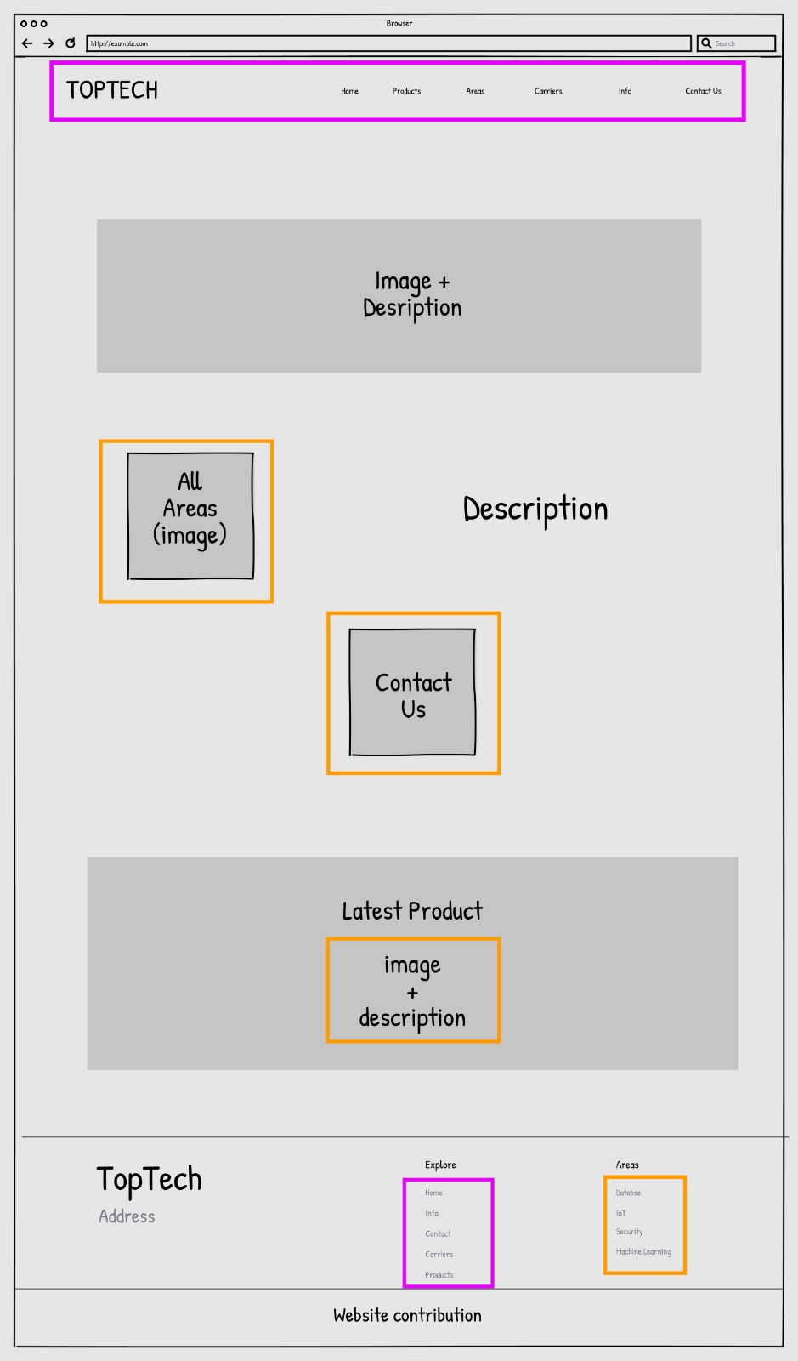

Wireframe 1. Homepage



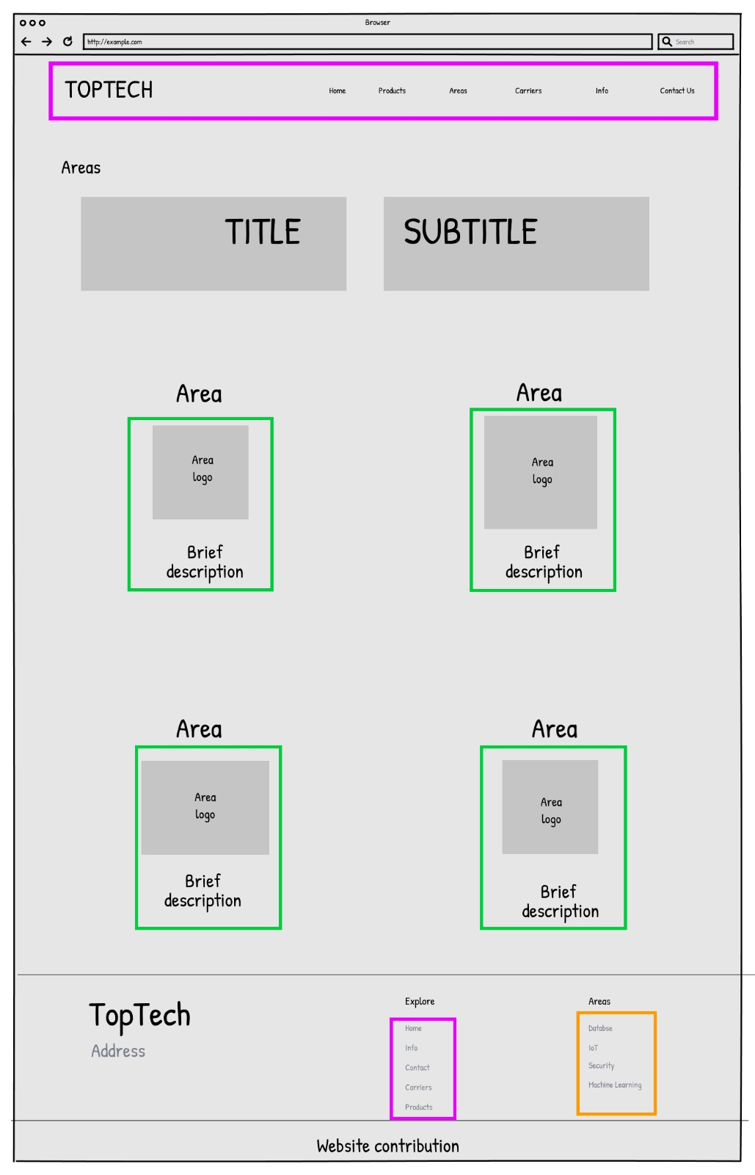

Wireframe 2. All Areas



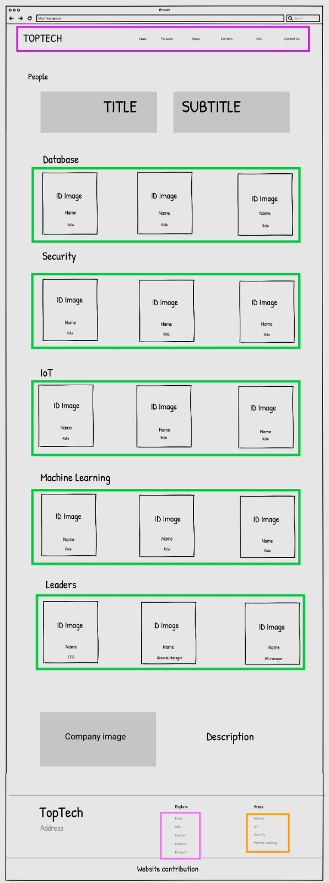

Wireframe 3. All People



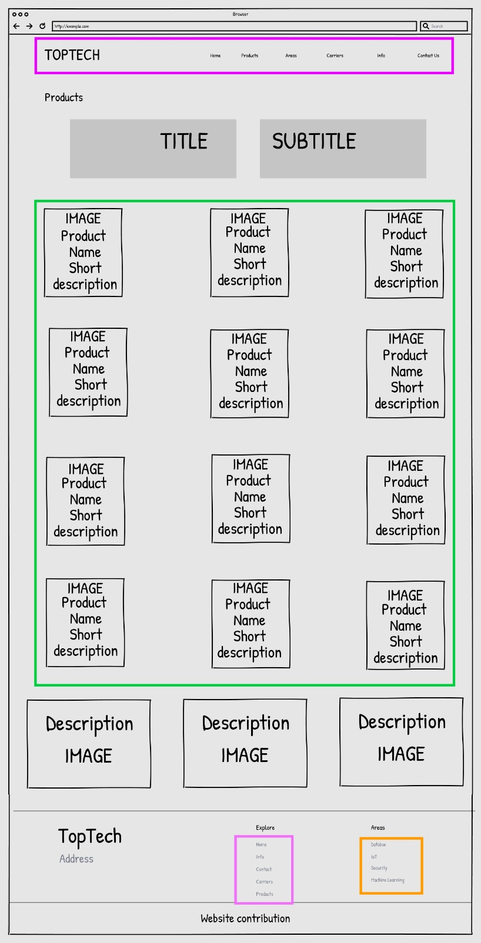

Wireframe 4. All Products



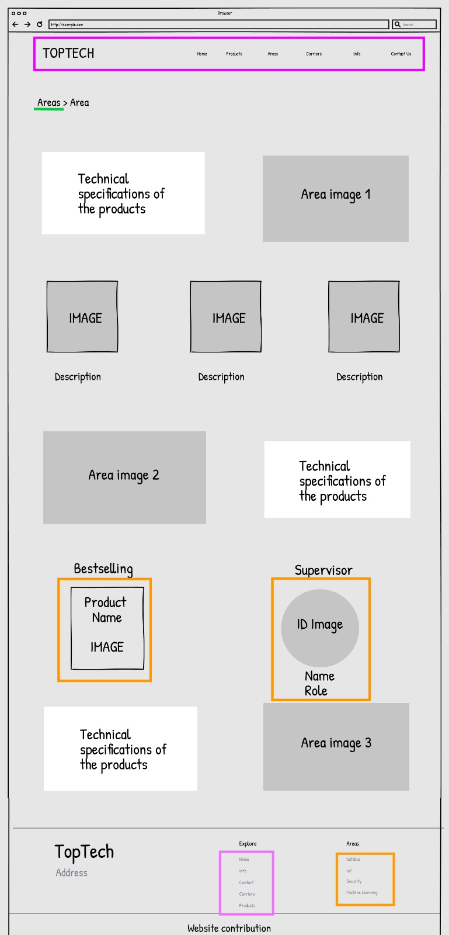

Wireframe 5. Kind of Topic Area



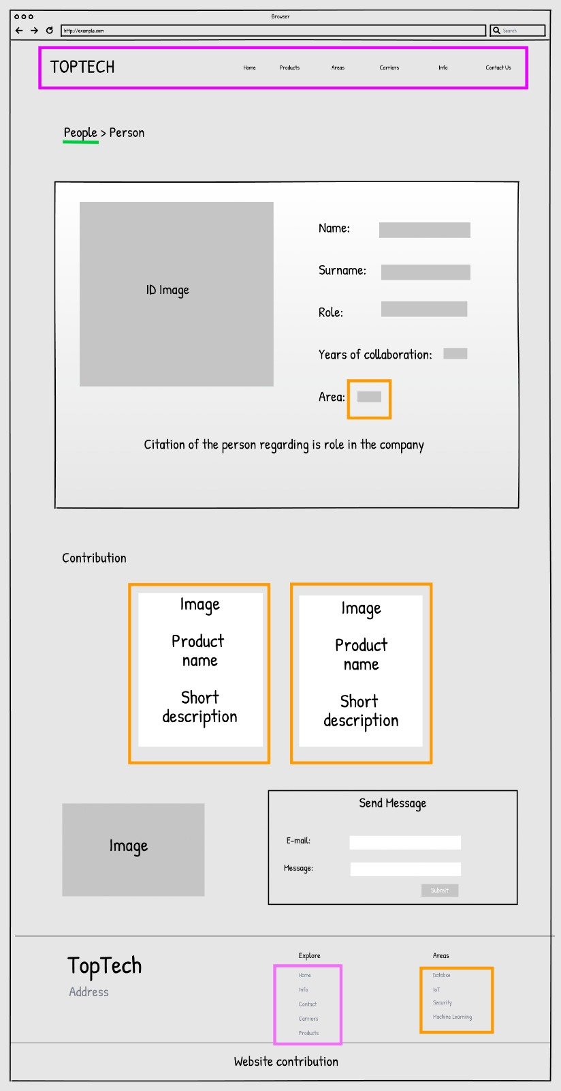

Wireframe 6. Kind of Topic Person



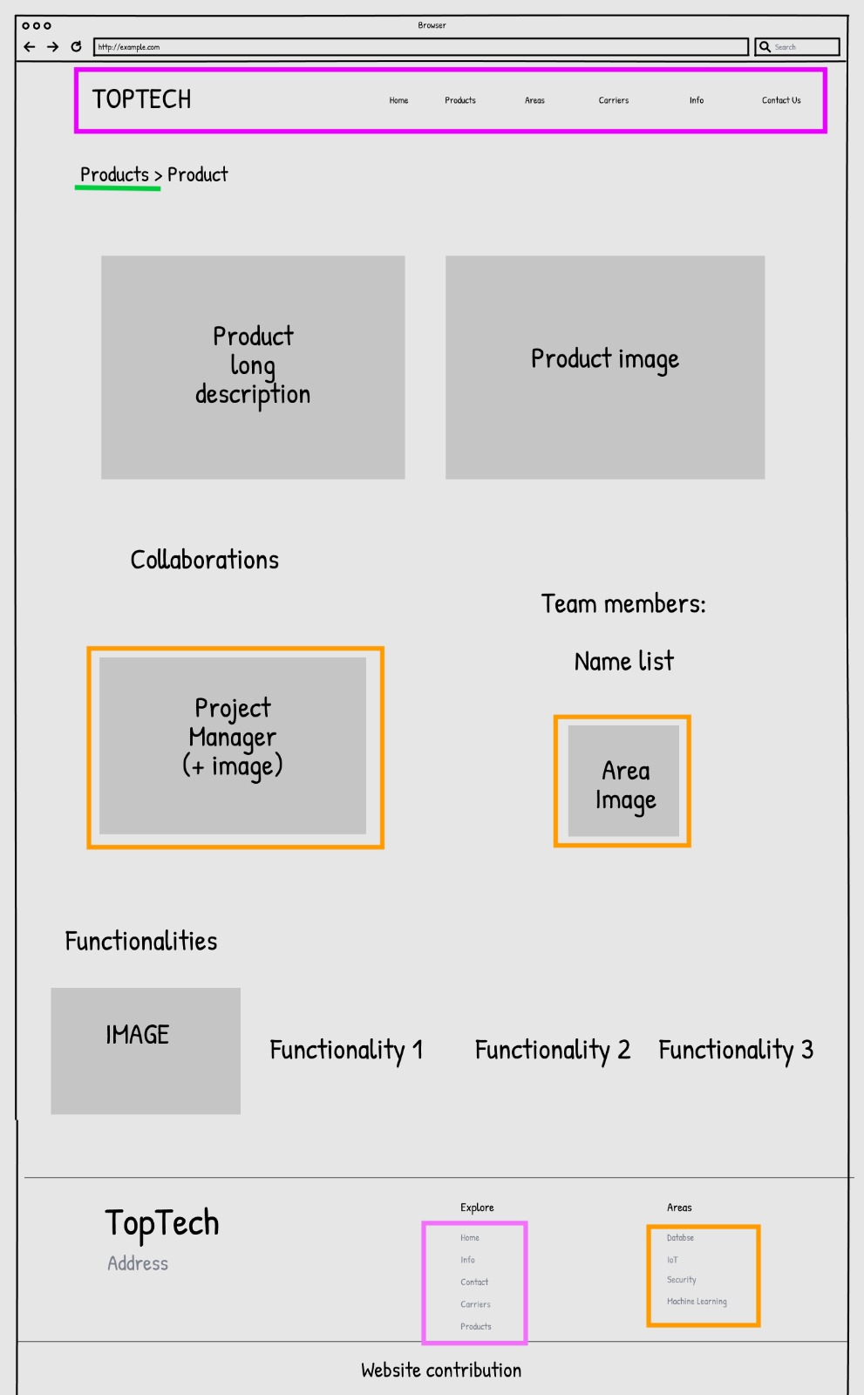

Wireframe 7. Kind of Topic Product



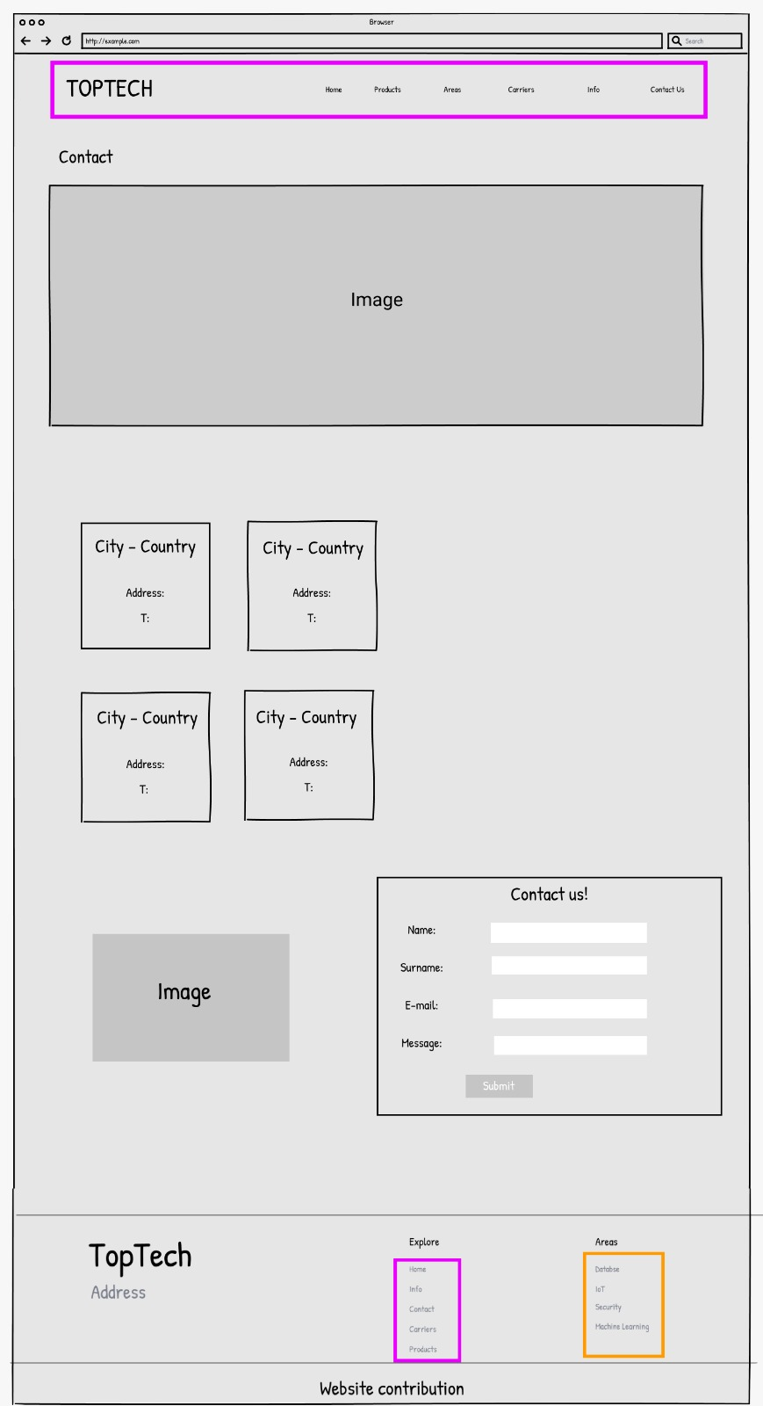

Wireframe 8. Topic Contact



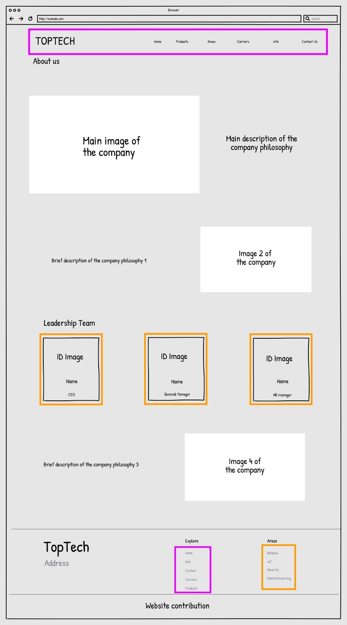

Wireframe 9. Topic AboutUs

* 1. Commented high fidelity wireframes

While the wireframes allowed an approximate visualization of the design, screenshots show the final version of the main pages of our website. Screenshots refer to the same pages as the wireframes with the addition of the Homepage one.

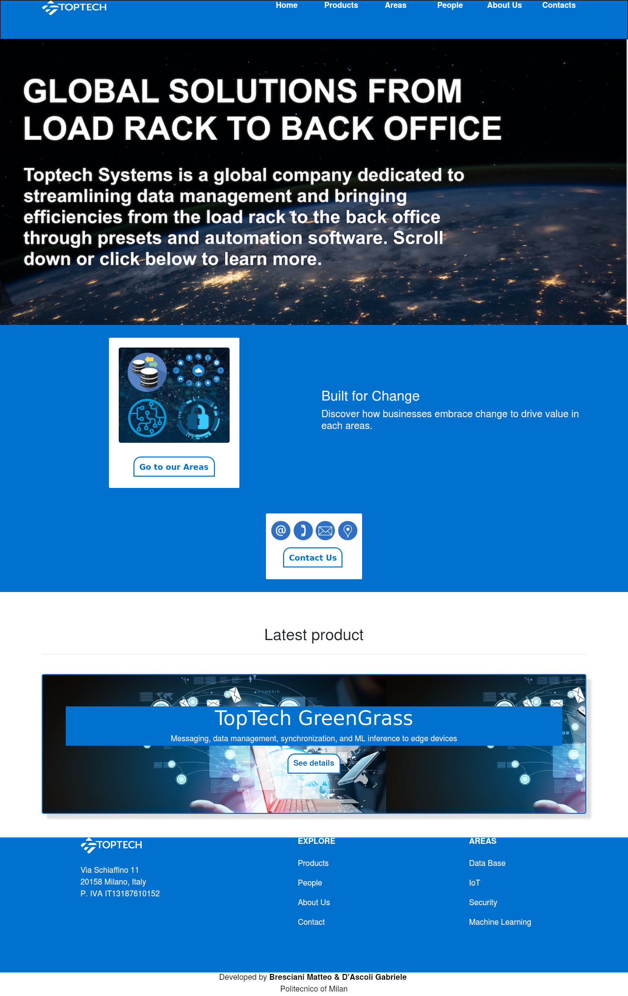

Wireframe HF 1. Home page

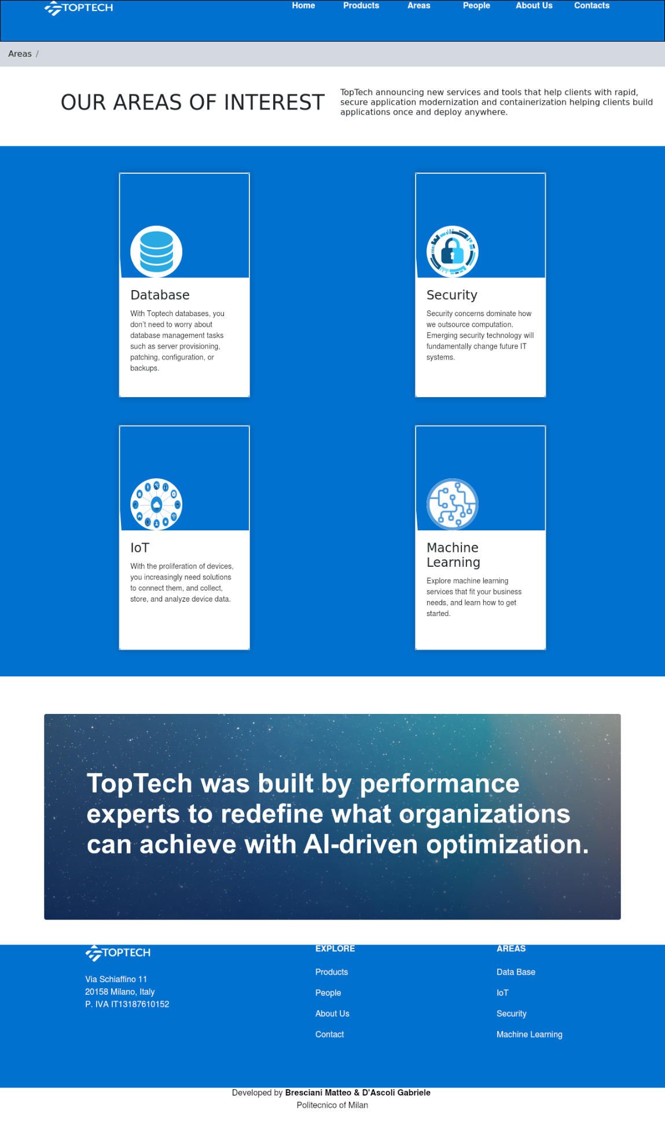

Wireframe HF 2. All Areas

GROP OF TOPICS: ALL PRODUCTS This is the introductory page for products and it contains the list of them. Every image is a GROUP LINK that allows user to open and read specific information about it or to go to related areas.

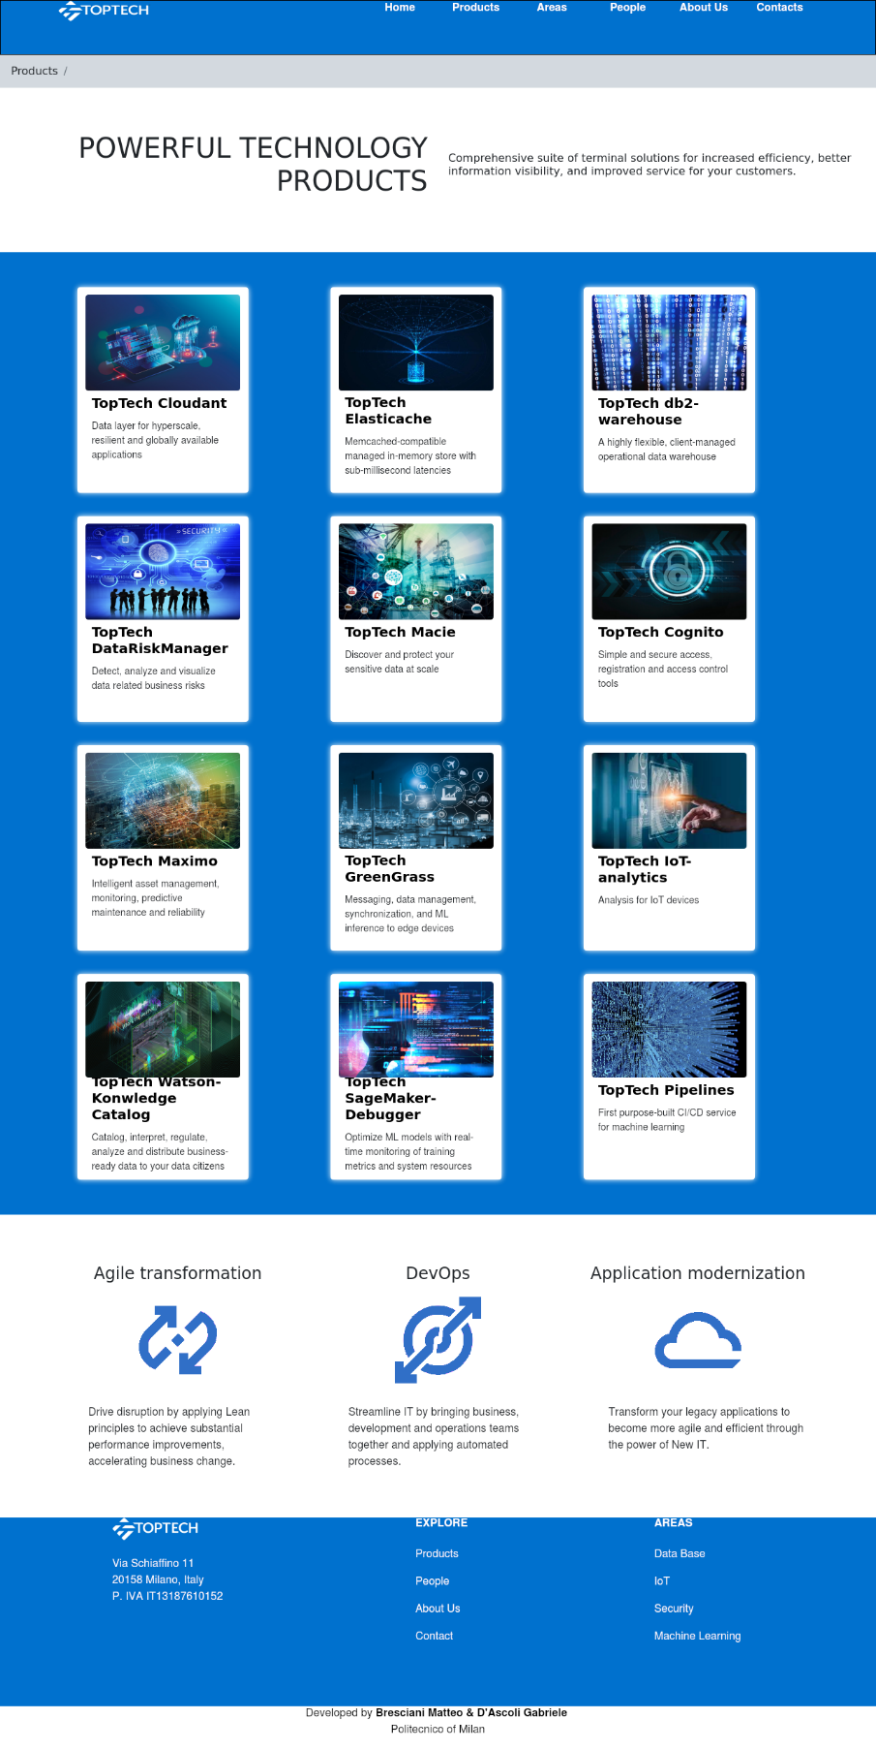

Wireframe HF 3. All Products

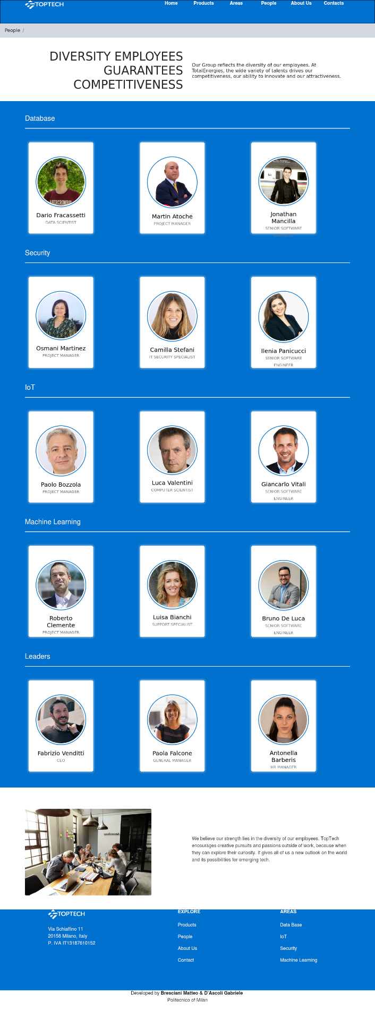

Wireframe HF 4. All People

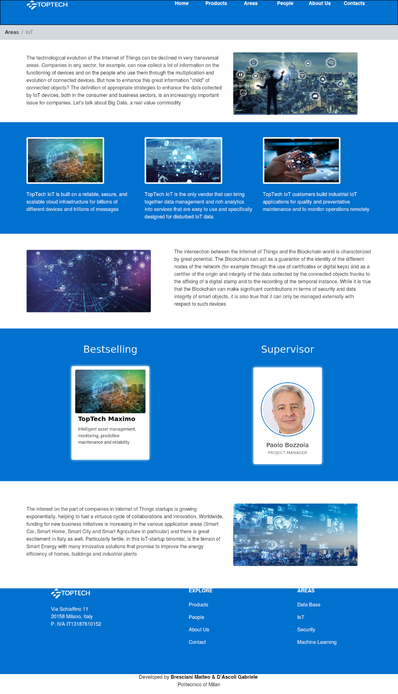

Wireframe HF 5. Kind of topic Area

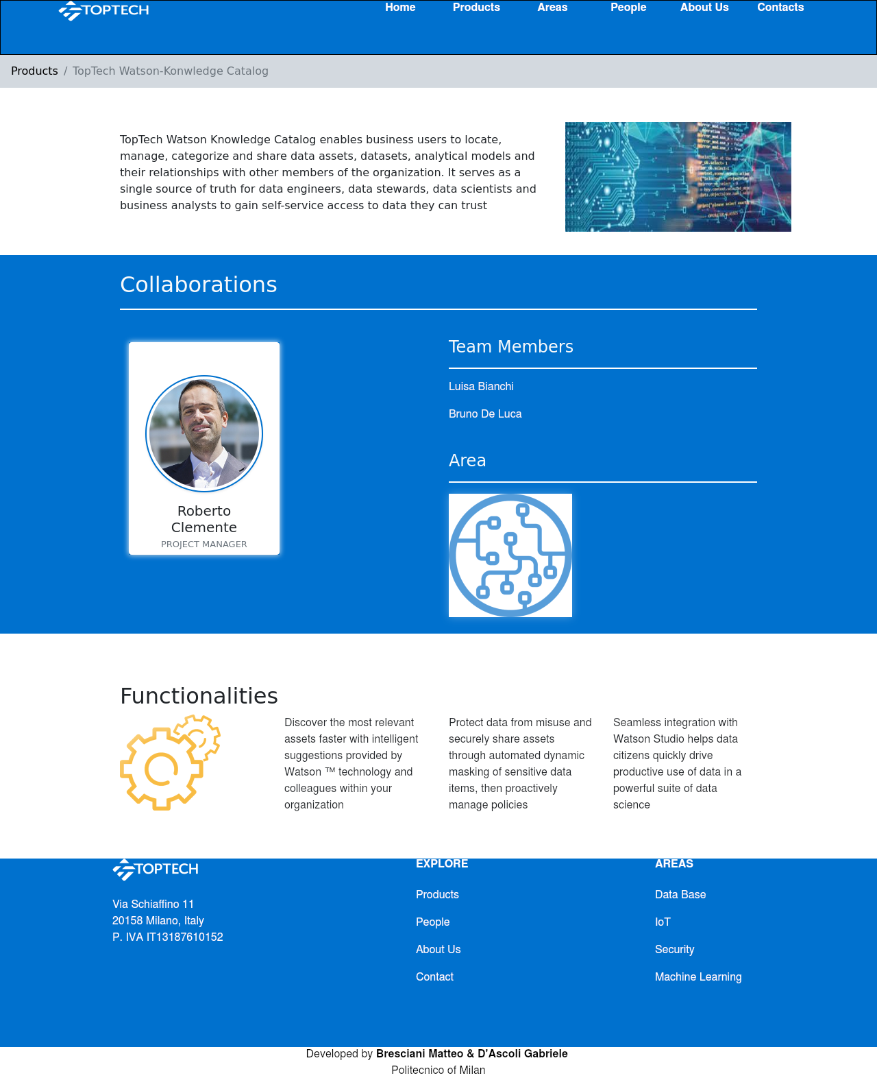

Wireframe HF 6. Kind of Topic Product

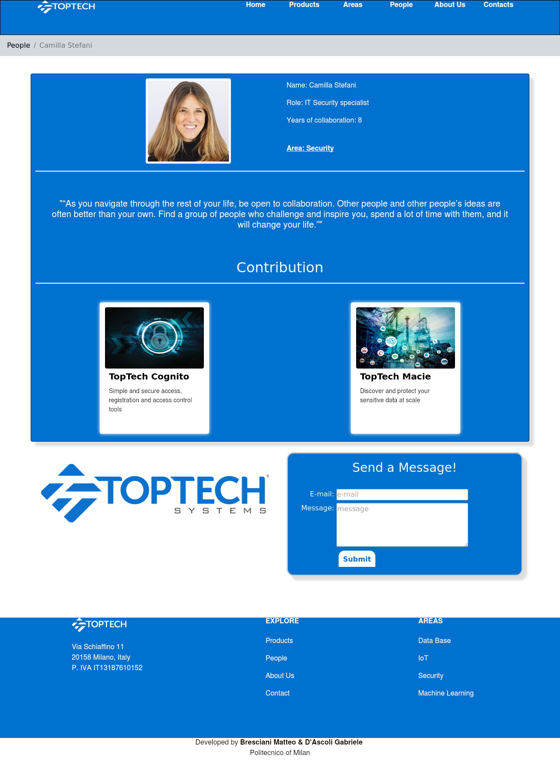

Wireframe HF 7. Kind of Topic: Person

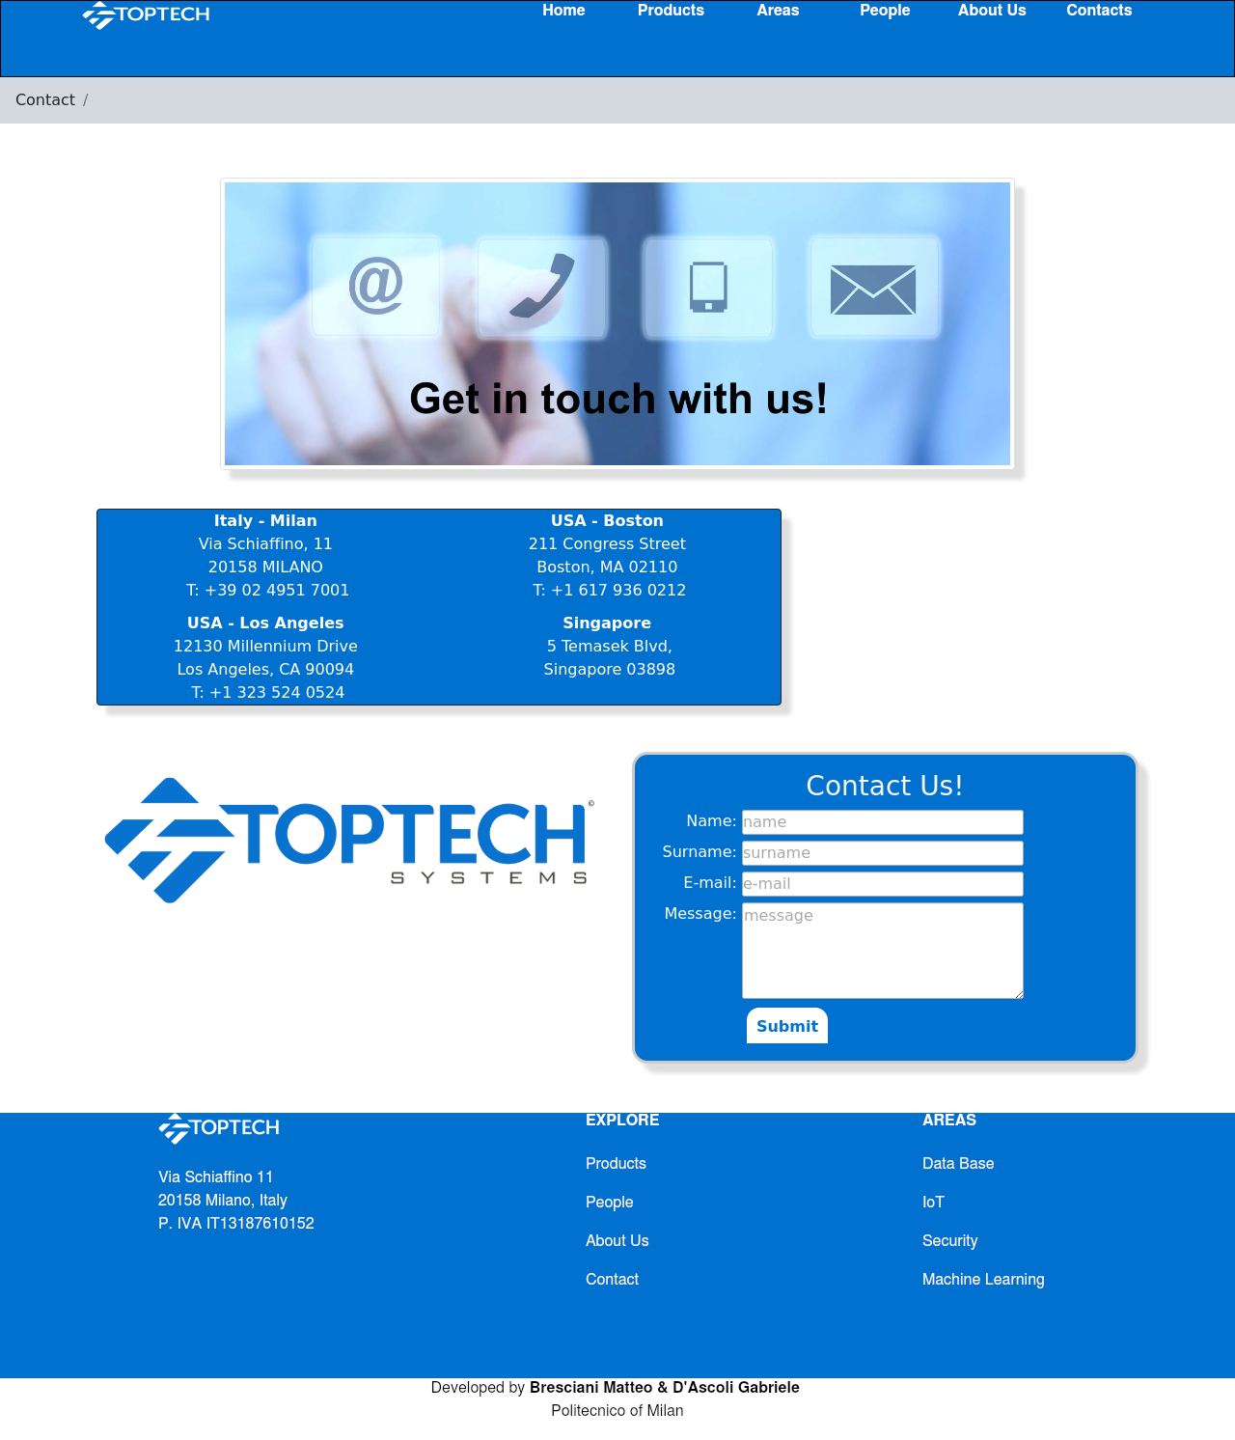

Wireframe HF 8. Topic: Contact

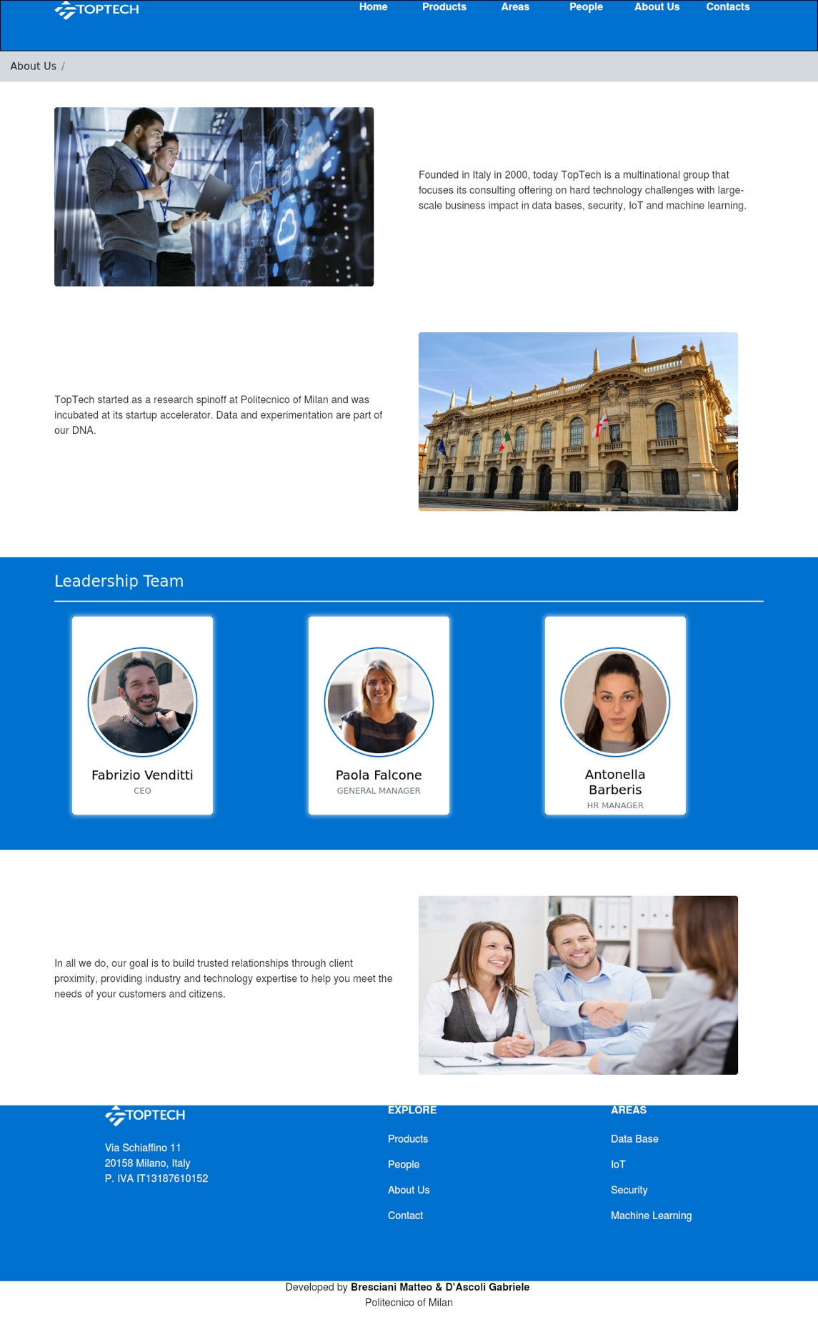

Wireframe HF 9. Topic About us

1. **Scenarios**

The following chapter will focus on the presentation of general scenarios, which are “a narrative description of what people do and experience as they try to make use of computer systems and applications” (M. Carrol, “Scenario-based Design”, Wiley, 1995); each scenario describes a possible usage of the web site by the users in real life and presented in order of complexity.

6.1 Case 1

6.1.1 Textual narrative

**User profile**: a graduating computer engineer is looking for a company that will give him the opportunity to do an internship in the software development sector after graduation.

**Goals**: the user wants to contact the company to get information on vacant positions and to give his availability.

**Context**: the user visits the TopTech company website during a study break, looking for a way to submit his application.

**Tasks**: the user navigates through the sections of the website, accesses the Contacts section and fills out the appropriate form to communicate with the company by entering his data.

6.1.2 Sequence

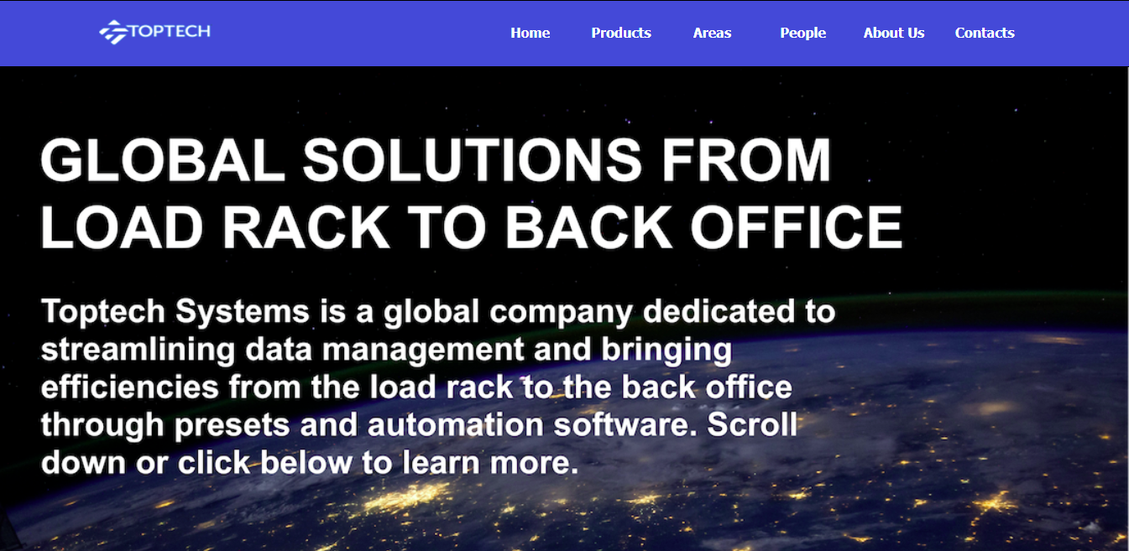

Figure 3. User visits the TopTech website and selects Contact

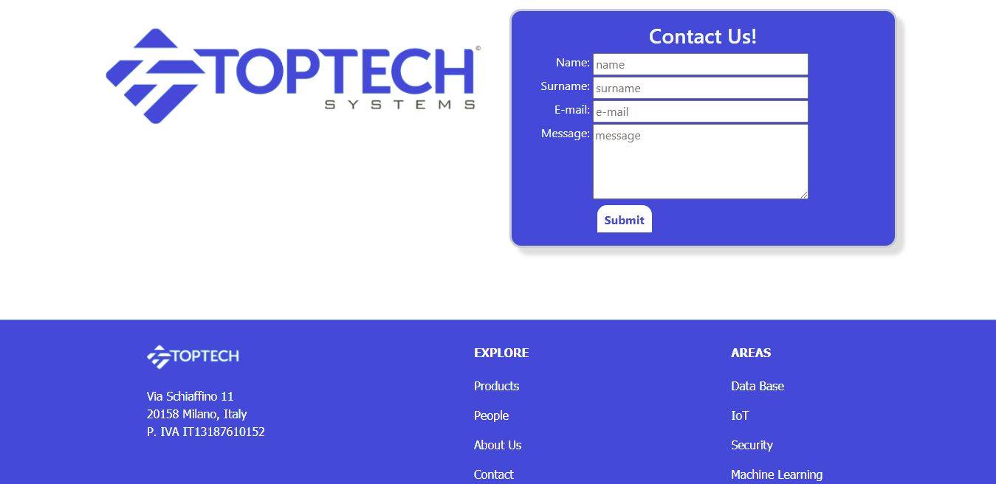

Figure 4. User visualize the Contact page and find the Contact form

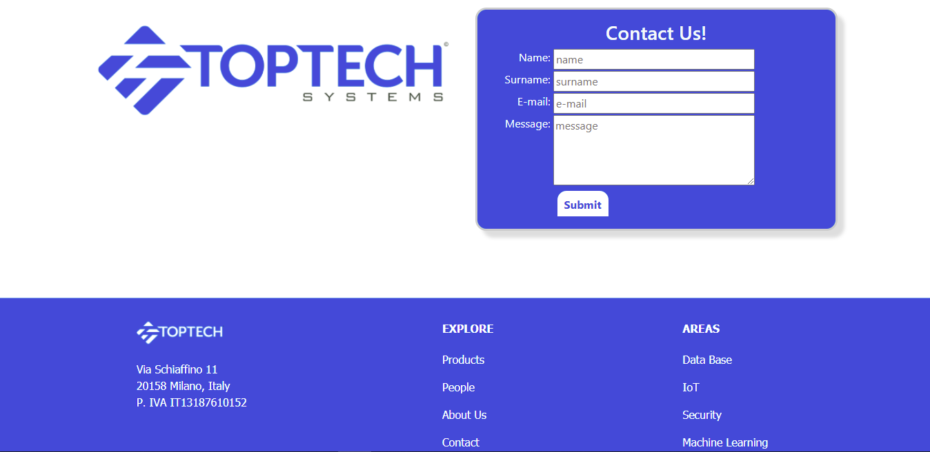

Figure 5. User fills the form with the required information and clicks Submit to send the request

6.2 Case 2

6.2.1 Textual narrative

**User** **profile**: a scientific informant in the IT sector is carrying out an IT company monitoring campaign on behalf of a company that deals with market analysis.

**Goals**: the user acquires information from the company's website about the best-selling product in the IoT sector among those proposed by the TopTech company.

**Context**: the expert within the monitoring campaign for which he is collaborating visits the TopTech website in search of the data he needs for his market analysis.

**Tasks**: the user visits the website of the TopTech company, navigates between the various sections and accesses the one relating to the treated areas; once you have chosen the IoT area you are interested in, you can view the bestselling product in that area and the page relating to it with all its technical specifications and functionalities.

6.2.2 Sequence

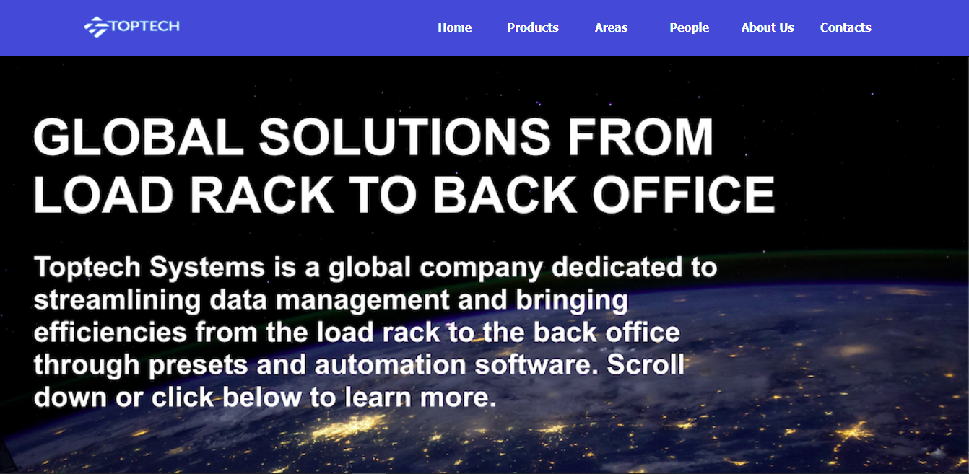

Figure 6. The expert visits the TopTech Company website and select Areas to access to the interested area

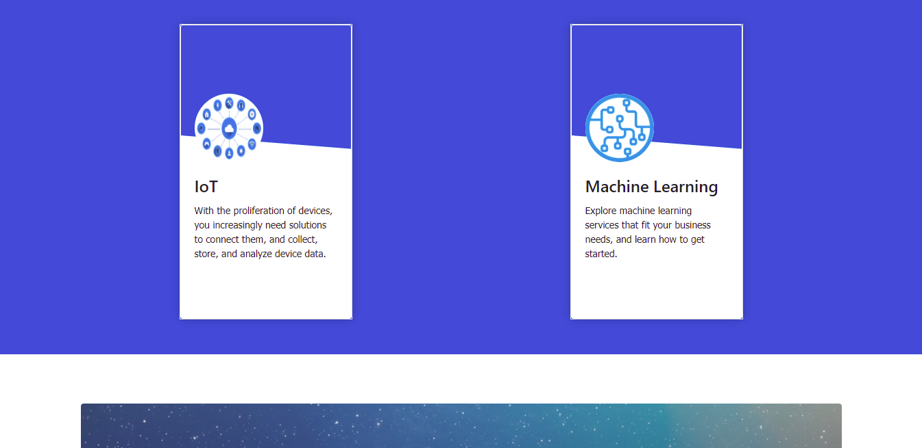

Figure 7. Once accessed to Areas section the user search and clicks on the IoT area

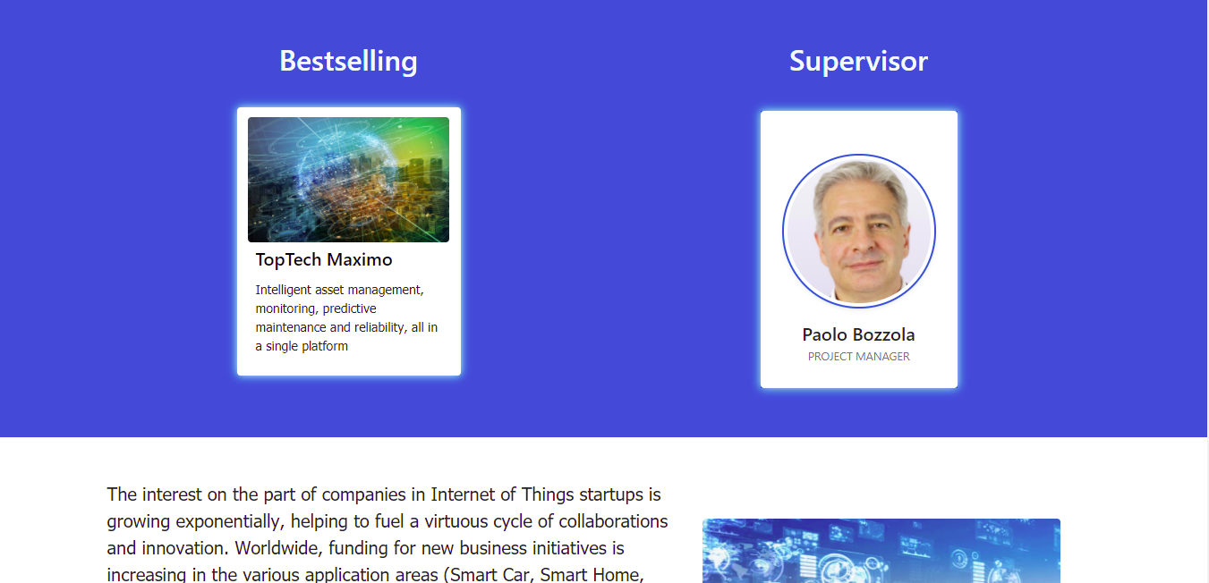

Figure 8. Scrolling down in the relative page the user visualize the Bestselling of the Area and click on it

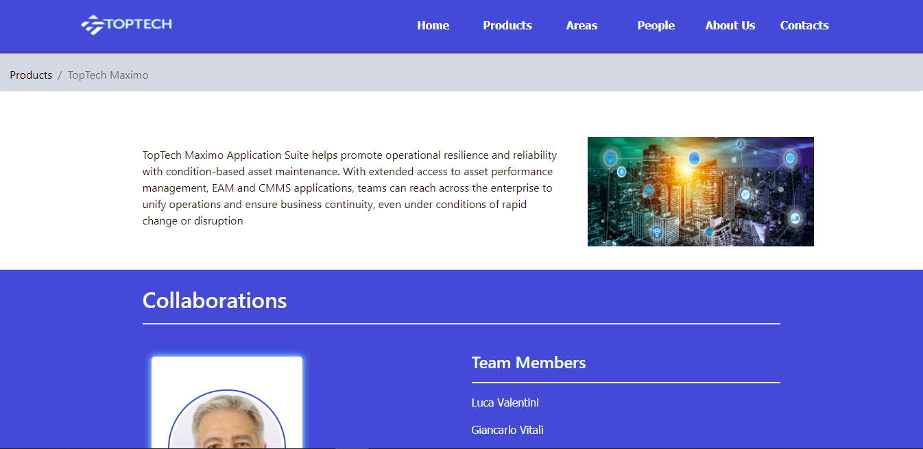

Figure 9. The user so access to the page of the Product and find all the related information

6.3 Case 3

6.3.1 Textual narrative

**User** **profile**: the data processing manager of a bank branch is testing a new TopTech Security IT sector product and is unable to fully utilize a particular feature.

**Goals**: the customer wants to contact the TopTech project manager responsible for product development to ask him for clarification on the use of the purchased product.

**Context**: the data processing manager, approaching the use of the new product at his workplace with data relating to the bank's customers, visits the TopTech website in search of information regarding the development team of the purchased product and a way to contact the project manager directly.

**Tasks**: the customer visits the website of the TopTech company, navigates between the sections of the site and accesses the Products section; at this point he searches for the purchased product among those offered by the company, accesses its relative page within which he will find the person at the head of the research team. At this point, the customer accesses the project manager's card and, by entering their data, uses the appropriate contact form to interact directly with the manager and expose the matter to him.

6.3.2 Sequence

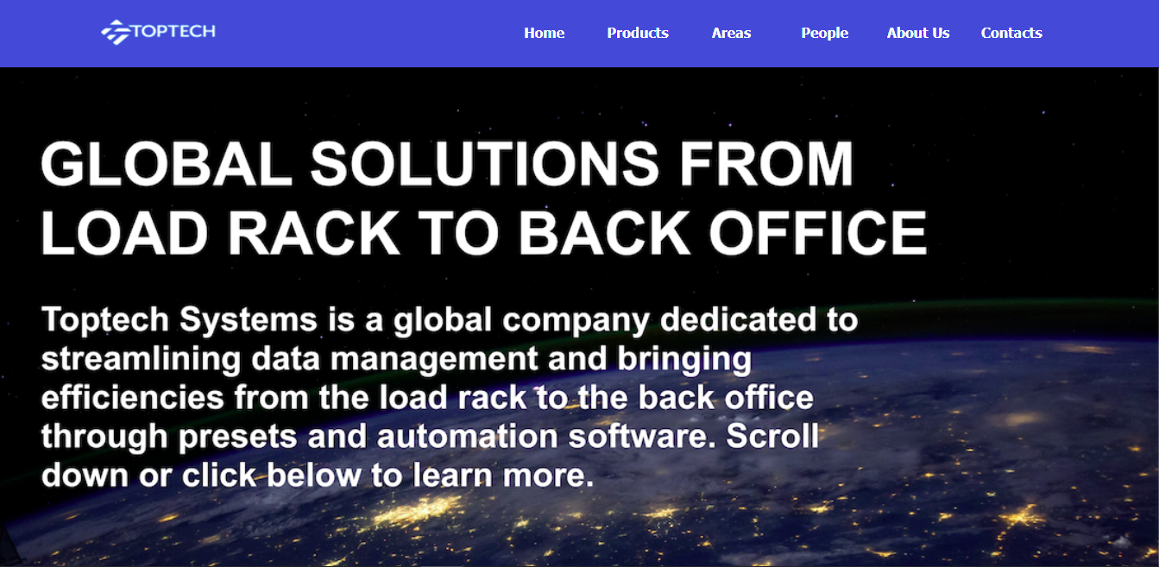

Figure 10. The customer visits the Website of the TopTech company and select the Products section

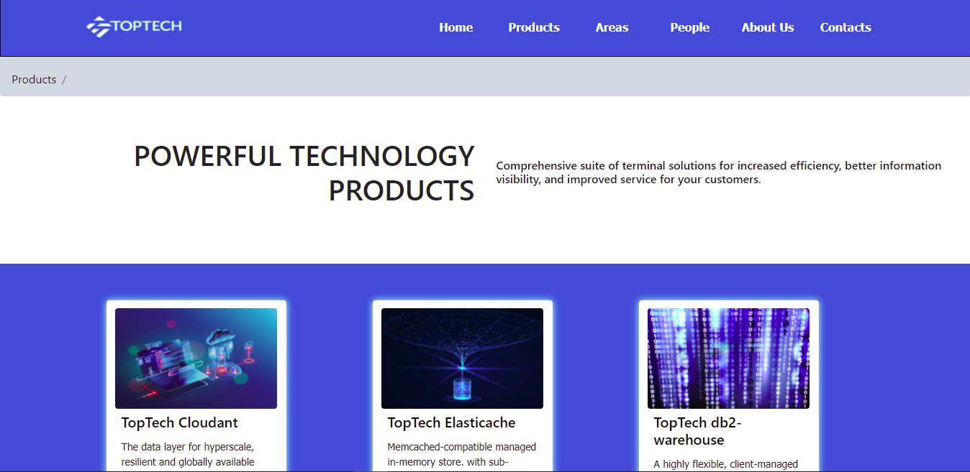

Figure 11. The user access to the page containing all the TopTech products

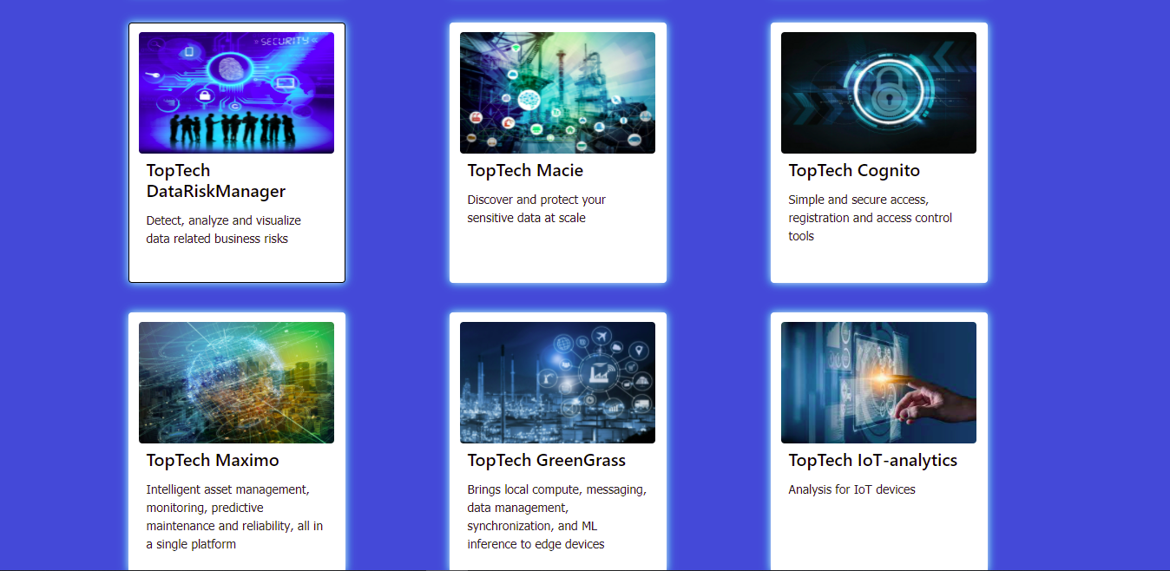

Figure 12. Scrolling down in the page the customer finds and clicks on the purchased product

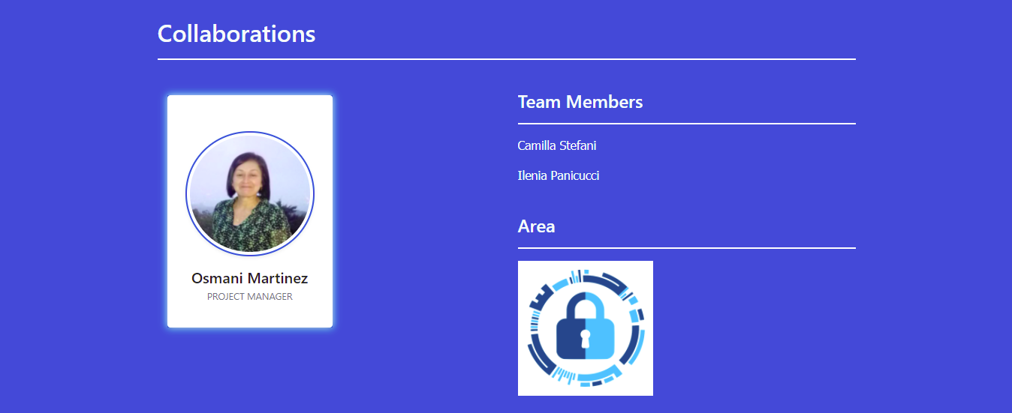

Figure 13. Once accessed to the relative page the user visualize and clicks on the person leading the team

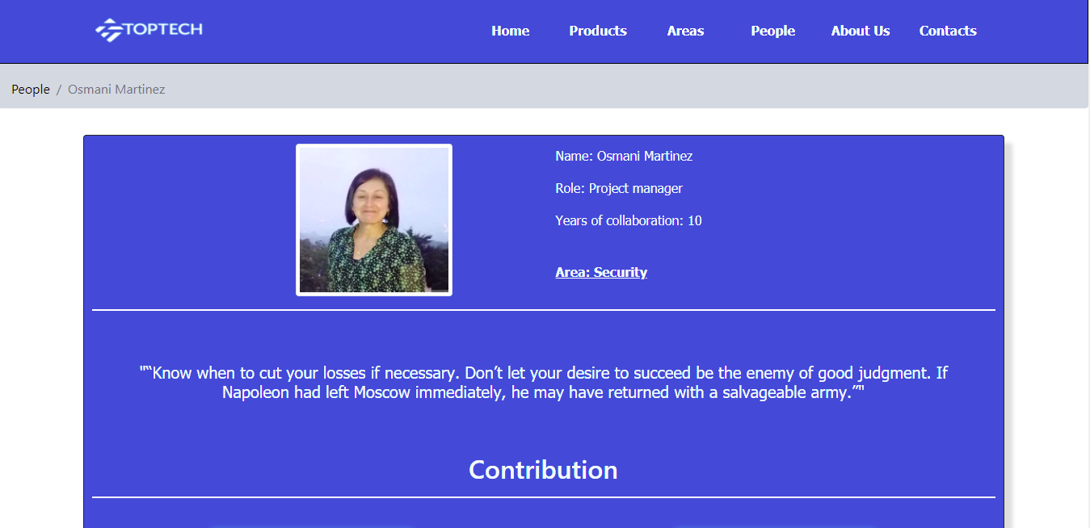

Figure 14. The customer enters into the personal page of the Project Manager

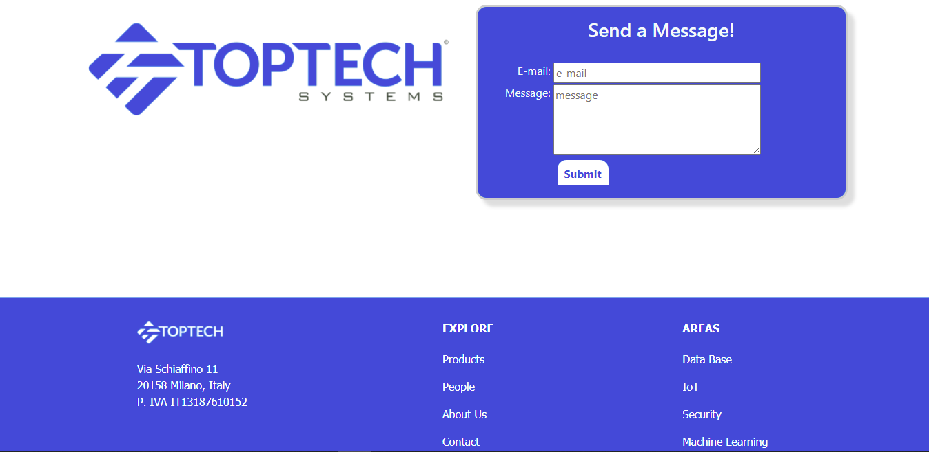

Figure 15. In this page the customer uses the form to keep in contact directly with the person in charge

1. **DB Design**
   1. ER



The Area, Person and Product databases are closely related:

* Each Product belongs to at most one Area and can be made by more People (at most 3)
* Each Person works at most in one Area and can contribute for more Products (at most 3)
* Each Area is associated to more People and more Products (at most 3)

Contact and About Us entities don’t have a relationship.

* 1. Relational tables

For our WebApp we saved informations into Databases to keep them stored in an organized way and we have used PostgreSQL as DBMS.

We created a DB for: the service Area (tab 8.1), Product (tab 8.2), Person for the people working in ICTea (tab 8.3) and AboutUs (tab 8.4). We have also initialized databases which will then be filled in by the user for the ContactUs (tab 8.5) sections.

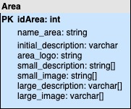

Table 1

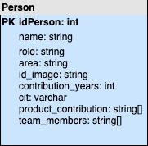

Table 3

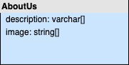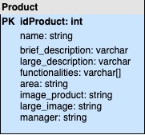

Table 4

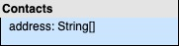

Table 2

Table 5